**Experiment No. 07**

* 1. **Experiment Name**

Write a program to draw the zero, positive, and negative sequence components of a given unbalanced system

* 1. **Objectives**
* To become acquainted with the balance and unbalance system
* To understand the algorithm and generate a MATLAB code for zero, positive, and negative sequence components of a given unbalanced system
* To get familiar with the procedure of designing and analyzing a power system in MATLAB
  1. **Theory**

An unbalanced system of n related phasors can be resolved into n systems of balanced phasors called the symmetrical components of the original phasors. In a three- phase system which is normally balanced, unbalanced fault conditions generally cause unbalanced currents and voltages to exist in each of the phases.

Three unbalanced phasors of a three-phase system can be resolved into three balanced systems of phasors. The balanced sets of components are:

* **Positive-sequence** components consisting of three phasors equal in magnitude, displaced from each other by 120o in phase, and having the same phase sequence as the original phasors
* **Negative-sequence** components consisting of three phasors equal in magnitude, displaced from each other by 120o in phase, and having the phase sequence opposite to that of the original phasors, and
* **Zero-sequence** components consisting of three phasors equal in magnitude and with zero phase displacement from each other.

Since each of the original unbalanced phasors is the sum of its components, the original phasors expressed in terms of their components are,

$$V_{a}= V_{a}^{\left(0\right)}+V_{a}^{\left(1\right)}+V_{a}^{\left(2\right)}$$

$$V_{b}= V_{b}^{\left(0\right)}+V_{b}^{\left(1\right)}+V_{b}^{\left(2\right)}= V_{a}^{(0)}+a^{2}V_{a}^{(1)}+aV_{a}^{(2)}$$

$$V_{c}= V_{c}^{(0)}+V_{c}^{(1)}+V_{c}^{(2)}= V_{a}^{(0)}+aV_{a}^{(1)}+a^{2}V_{a}^{(2)}$$

Where,

|  |  |  |
| --- | --- | --- |
| $$V_{a}^{(0)}=\frac{1}{3}(V_{a}+V_{b}+V_{c})$$ | $$V_{a}^{(1)}=\frac{1}{3}(V_{a}+{aV}_{b}+a^{2}V_{c})$$ | $$V_{a}^{(2)}=\frac{1}{3}(V_{a}+{a^{2}V}_{b}+aV_{c})$$ |

For this experiment, we will consider a system having following values draw theirzero, positive, and negative sequence respectively.

|  |  |  |
| --- | --- | --- |
|  |  |  |

* 1. **Required apparatus**
* MATLAB
  1. **Algorithm**

1. Start
2. Provide magnitude and phase of three unbalanced voltage
3. Provide the value of operator ***a***
4. Calculate the values of zero sequence components
$$V_{a}^{(0)}=\frac{1}{3}\left(V_{a}+V_{b}+V_{c}\right), { V}_{a}^{(0)}=V_{b}^{(0)}=V_{c}^{(0)}$$

5. Calculate the values of positive sequence components
$$V_{a}^{(1)}=\frac{1}{3}\left(V_{a}+{aV}_{b}+a^{2}V_{c}\right), V_{b}^{\left(1\right)}=a^{2}V_{a}^{(1)}, V_{c}^{(1)}= aV_{a}^{(1)}$$

6. Calculate the values of negative sequence components
$$V_{a}^{(2)}=\frac{1}{3}\left(V_{a}+{a^{2}V}_{b}+aV_{c}\right), V_{b}^{\left(2\right)}=aV_{a}^{\left(2\right)}, V_{c}^{(2)}= a^{2}V_{a}^{(2)}$$

7. Calculate original sequence
8. Plot and display the diagram
9. End
   1. **Flow chart**

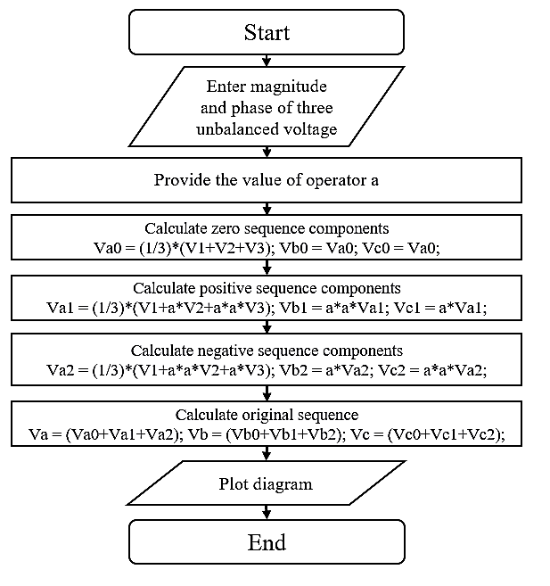

* 1. **MATLAB Code & Output**

clc; %Clears previous data from command window

clear all; %Removes all variables from the current workspace

% magnitude and phase of unbalanced voltage V1

M1 = input('Enter magnitude of V1:');

P1 = input('Enter phase of V1:');

V1 = M1.*exp(j*deg2rad(P1))

% magnitude and phase of unbalanced voltage V2

M2 = input('Enter magnitude of V2:');

P2 = input('Enter phase of V2:');

V2 = M2.*exp(j*deg2rad(P2))

% magnitude and phase of unbalanced voltage V3

M3 = input('Enter magnitude of V3:');

P3 = input('Enter phase of V3:');

V3 = M3.*exp(j*deg2rad(P3))

% calculate a

a = 1.*exp(j*2*pi/3);

anew = a.*a;

% finding zero sequence

Va0 = (1/3)*(V1+V2+V3);

Vb0 = Va0;

Vc0 = Va0;

% finding positive sequence

Va1 = (1/3)*(V1+a*V2+anew*V3);

Vb1 = anew*Va1;

Vc1 = a*Va1;

% finding negative sequence

Va2 = (1/3)*(V1+anew*V2+a*V3);

Vb2 = a*Va2;

Vc2 = anew*Va2;

% finding original sequence

Va = (Va0+Va1+Va2);

Vb = (Vb0+Vb1+Vb2);

Vc = (Vc0+Vc1+Vc2);

% plotting unbalanced sequence

subplot(2,3,1);

compass([V1,V2,V3]);

title('Unbalanced Sequence');

% plotting zero sequence

subplot(2,3,2);

compass([Va0,Vb0,Vc0]);

title('Zero Sequence');

% finding positive sequence

subplot(2,3,3);

compass([Va1,Vb1,Vc1]);

title('Positive Sequence');

% finding negative sequence

subplot(2,3,4);

compass([Va2,Vb2,Vc2]);

title('Negative Sequence');

% finding original sequence

subplot(2,3,6);

compass([Va,Vb,Vc]);

title('Original Sequence');

**Output**

Enter magnitude of V1:10

Enter phase of V1:90

Enter magnitude of V2:5

Enter phase of V2:30

Enter magnitude of V3:15

Enter phase of V3:210

**Diagram**



* 1. **Discussion & Conclusion**

In this experiment, we designed an algorithm, flow chart, and programmed a generalized code for zero, positive, and negative sequence components of a given unbalanced system. Here, we provided the values from and formulated necessary condition to assign values to variables. The only adjustment to the code we may need is changing the input values of the file to work with. Through this generalized coding format, we easily designed our desired output.